**PROJECT CONFIGURTION MANAGEMANT USING ANSIBLE**

**Team Name**

GAME CHANGERS

**Mentors**

Bobby sir

Surya Ashok sir

**Team Members**

1 Sriram Teja

2 Surya Naveen

3 Ramayya Naidu

4 Sai Krishna

**Ansible:**

1. Ansible is an open source Automation Tool used for the Configuration management, Application Deployment and Task automation.
2. Ansible is a game changer in how you manage the infrastructure. It allows users to automate repetitive tasks.
3. Ansible allows you to configure not just one computer, but potentially a whole network of computers at once.
4. It is widely used by the system administrators, developers, and DevOps engineers to automate and manage complex IT infrastructure.

**Features of Ansible:**

1. Python - ansible is a DevOps tool which is written in python programming language.
2. SSH - secured shell keys with port number (22) are used in ansible to allows Ansible to communicate to the target machines through normal SSH command line.
3. Push architecture – Push the necessary configurations to the clients. All you have to do is, write down those configurations (playbook) and you can see how powerful all nodes will access that configuration.
4. Parallel Execution: Ansible can execute task in parallel which makes it more efficient and faster than other automation tools. This is particularly useful for managing large scale environments.
5. Extensibility: Ansible can be extended using plugins, which allows you to add custom functionality to the tool.

**Why Ansible?**

Ansible is a Powerful Automation Tool that can be used to automate repetitive and time consuming , such as application deployment and infrastructure provisioning.

Reasons to choose ansible

1. **Simple to use:** Ansible uses a simple and easy-to-understand language, YAML, to define automation tasks. This makes it easy for even non-programmers to get started with automation.
2. **Agentless:** Ansible is agentless, meaning that it does not require any software to be installed on the target servers. This makes it easy to manage and reduces the overhead of managing agents.
3. **Cross-platform support**: Ansible can manage a wide variety of systems, including Linux, macOS, Windows, and network devices.
4. **Idempotent:** Ansible is designed to be idempotent, which means that it can be run multiple times without causing any unintended side effects.

**How Ansible works:**

In ansible there are two categories

1. control node:

The control node is a computer that runs Ansible There must be at least one control node, although a backup control node may also exist.

1. managed nodes:

A managed node is any device being managed by the control node.

Ansible works by connecting to nodes (clients, servers, or whatever you're configuring) on a network, and then sending a small program called an Ansible module to that node. Ansible executes these modules over SSH and removes them when finished. The only requirement for this interaction is that your Ansible control node has login access to the managed nodes. SSH keys are the most common way to provide access, but other forms of authentication are also supported.

**Example:**

The system administrator Sam, he is responsible for his company’s infrastructure.

He must maintain at least 3 webservers as well as 2 database servers i.e. MYSQL

Then it will be easy to maintain but if we require more number of servers it is difficult to the same task must be repeated multiple times. Moreover, humans are prone to make errors

With ansible a code is written once for the installation and deployed multiple times

**Architecture of Ansible:**

* The machine where ansible install is called local machine
* The local machines consists of module and inventory.
* Basically, a module is a command or set of similar commands meant to be executed on the client-side. And it is the collection of configuration code files the configuration code files are called as playbooks
* Inventory is a file containing data about the ansible client servers (Host file / Inventory file)
* Playbook: It consists of code in YAML format, which describes tasks to be executed

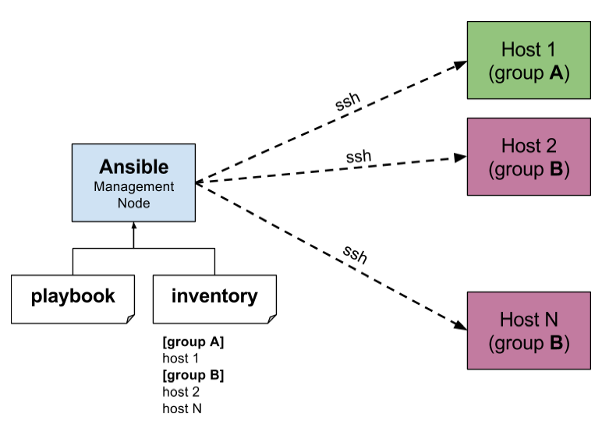

**PLAYBOOK:**

-->Play books are the set of instructions to configure the nodes

-->They are written in a YAML(Yet Another markup language) a language used to describe data.

-->A playbook is a list of plays, host is the target for the play.

-->Each play has a list of tasks.

-->Each element in a list of tasks given a name.

-->The name is followed by instructions to execute the task.

**Advantages of Ansible:**

1. Simple and easy to learn: Ansible uses YAML syntax, which is easy to read and write. The simplicity of the language makes it easy for beginners to learn and use.
2. Efficient and fast: Ansible uses SSH to communicate with the remote hosts, making it a lightweight and fast automation tool. It also uses a push-based approach, which means it can execute tasks in parallel, making it more efficient.
3. Powerful. App deployment. Configuration management. Workflow orchestration. Orchestrate the app lifecycle.

Note: Workflow orchestration: it handles multiple automated tasks to execute a single significant process or workflow.

1. Human readable automation. No special coding skills needed. Tasks executed in order. Get productive quickly.

**Disadvantages of Ansible:**

1. Steep learning curve for complex tasks: While Ansible is simple and easy to learn, complex tasks can be more difficult to accomplish. Advanced use cases may require more knowledge of programming and the underlying infrastructure.
2. Limited functionality: Although Ansible can be used for a wide range of tasks, it has some limitations in terms of functionality. Some more complex tasks may require additional tools or plugins.
3. Security concerns: As with any automation tool, there are security concerns to consider when using Ansible. If not properly secured, Ansible can pose a security risk to your infrastructure.
4. Resource requirements: Ansible can require significant resources, particularly when running on large-scale environments. This can impact performance and increase the overall cost of using the tool.

**Applications:**

Ansible can be used to provision the underlying infrastructure of your environment, virtualized hosts and hypervisors, network devices, and bare metal servers.

**Conclusion:**

1. Ansible is a powerful and versatile tool for project configuration management.

Its agentless architecture, simple and easy to learn language, and modular architecture

2.Overall Ansible is an excellent choice for Project Configuration Management provide a simple and efficient way to manage complex IT infrastructure